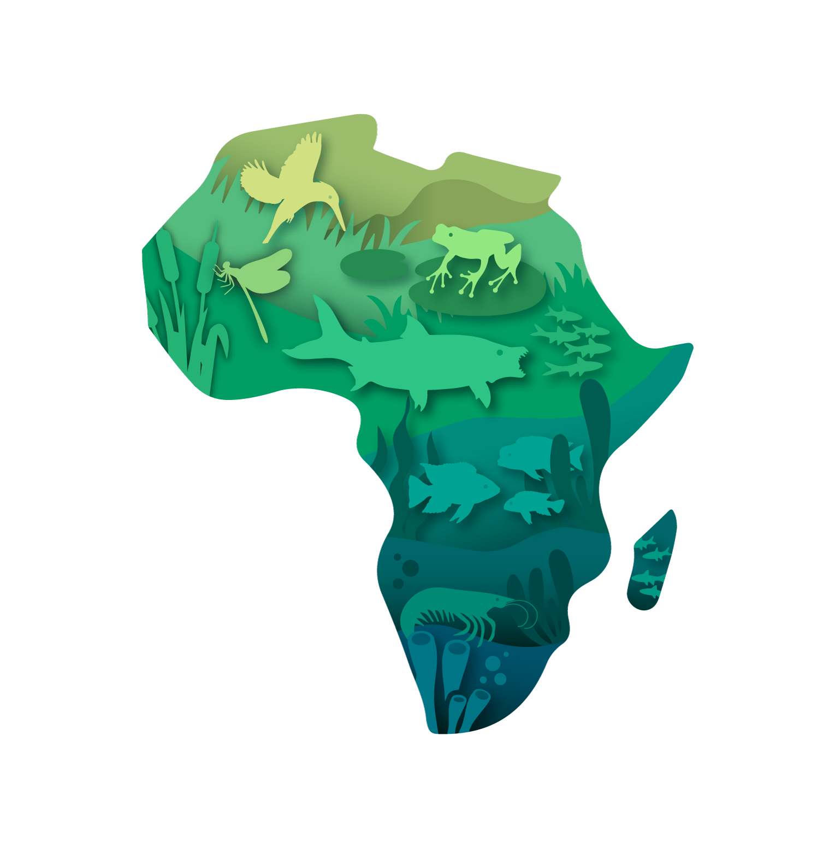

FBIS Africa Freshwater Biodiversity Data Mobilisation Small Grant
Application Form
Grant amount: USD 5,000–10,000 (depending on quantity and quality of data records)
Grant period: January–June 2027 (6 months)
Application deadline: 30 October 2026
Submit to: jeremy@frcsa.org.za
Please read the Call for Applications before completing this form. All occurrence records proposed for mobilisation must not already be published to GBIF and must contain, at minimum, a taxon name, sampling date and spatial coordinates. All records mobilised through the grant will be published to FBIS-Africa and pushed to GBIF.

1. Applicant Information

Project title:
Click or tap here to enter text.

Applicant organisation/institution:
Click or tap here to enter text.

Country:
Click or tap here to enter text.

Type of organisation:
☐ University / research institution
☐ Museum / natural history collection
☐ Government department / agency
☐ Non-governmental organisation
☐ Research or conservation programme
☐ Other: Click or tap here to enter text.

Project Leader
Full name: Click or tap here to enter text.
Position: Click or tap here to enter text.
Email: Click or tap here to enter text.
Telephone (including country code): Click or tap here to enter text.
☐ Project Leader CV attached: Yes

Additional Project Team Members
Applicants may include details for up to three additional team members.
 | Team Member 1 | Team Member 2 | Team Member 3
Full name | Click or tap here to enter text. | Click or tap here to enter text. | Click or tap here to enter text.
Organisation | Click or tap here to enter text. | Click or tap here to enter text. | Click or tap here to enter text.
Position/role | Click or tap here to enter text. | Click or tap here to enter text. | Click or tap here to enter text.
Email | Click or tap here to enter text. | Click or tap here to enter text. | Click or tap here to enter text.
Role in this project | Click or tap here to enter text. | Click or tap here to enter text. | Click or tap here to enter text.
Relevant expertise | Click or tap here to enter text. | Click or tap here to enter text. | Click or tap here to enter text.

2. Project Motivation
Why should these freshwater biodiversity data be mobilised and made openly accessible?
Briefly explain the importance of the dataset and how making it accessible could contribute to freshwater biodiversity conservation, management, research, monitoring or decision-making.

Maximum 300 words
Click or tap here to enter text.

3. Dataset Information

Dataset overview
Dataset name/title:
Click or tap here to enter text.

Taxonomic group(s):
☐ Freshwater fishes
☐ Amphibians
☐ Molluscs
☐ Crustaceans
☐ Odonata (dragonflies and damselflies)
☐ Ephemeroptera (mayflies)
☐ Plecoptera (stoneflies)
☐ Trichoptera (caddisflies)
☐ Megaloptera
☐ Other: Click or tap here to enter text.

Countries represented:
Click or tap here to enter text.

River basins/catchments/freshwater systems represented, where known:
Click or tap here to enter text.

Approximate date range of records: From: ____Click or tap here to enter text.____ To: ____Click or tap here to enter text.____

Number of records
Estimated number of unique biodiversity occurrence records that will be mobilised through this grant:
____Click or tap here to enter text.____ records

For this grant, a biodiversity occurrence record is an observation or collection of a particular taxon at a particular place and time.
Every proposed record must contain:
☐ Taxon name
☐ Sampling date
☐ Spatial coordinates (latitude and longitude)

Basis of record
Please indicate the basis of the occurrence records included in the proposed dataset (select all that apply):
☐ Visual / field observation
☐ Museum / preserved specimen
☐ eDNA record
☐ Other: Click or tap here to enter text.

Additional information
Please indicate additional information associated with the records, where available:
☐ Abundance
☐ Sampling method
☐ Sampling effort
☐ Photographs
☐ Habitat measurements
☐ Water-quality measurements
☐ Other environmental variables
☐ Other: Click or tap here to enter text.

Briefly describe the current format and condition of the data (e.g. spreadsheets, databases, transcribing hard-copy data sheets, museum records or records requiring digitisation):
Click or tap here to enter text.

4. GBIF Status and Data Sharing

GBIF status
Are any of the records for which you are requesting funding already published to GBIF?
☐ No
☐ Yes

Records already published to GBIF are not eligible for funding.
If part of a larger dataset has already been published to GBIF, briefly explain how you have identified and excluded these records from the number proposed above:
Click or tap here to enter text.

☐ I confirm that the number of records specified in Section 3 represents records that are not already published to GBIF: Yes

Data ownership and permissions
Who owns or is the custodian of the proposed dataset?
Click or tap here to enter text.

Does the applicant have the necessary authority/permission to mobilise and publish these data to FBIS-Africa and GBIF?
☐ Yes
☐ Permission will be obtained before publication
☐ No
If permission still needs to be obtained, please explain:
Click or tap here to enter text.

FBIS-Africa Data Sharing Agreement
Successful applicants will be required to sign an FBIS-Africa Data Sharing Agreement covering the mobilisation, sharing and publication of the funded data.
All occurrence records mobilised through this grant will be published to FBIS-Africa and pushed to GBIF.
☐ I confirm that, if successful, the applicant is willing and able to enter into the FBIS-Africa Data Sharing Agreement and agrees to publication of the mobilised records through FBIS-Africa and GBIF: Yes

5. Proposed Data Mobilisation Activities
Briefly describe how the proposed data will be mobilised and prepared for publication.
Maximum 300 words
Click or tap here to enter text.

FBIS-Africa Data Upload Template
All funded datasets must be formatted using the FBIS-Africa Data Upload Template available at https://fbisafrica.org/upload/. Support from the FBIS-Africa team will be available if needed.
☐ I confirm that the project team will format the funded data using the required FBIS-Africa Data Upload Template: Yes

6. Applicant Capacity
Briefly describe the project team's relevant experience and capacity to successfully complete the proposed work, including relevant expertise in freshwater biodiversity, taxonomy, biodiversity data management, digitisation, GIS/georeferencing or data mobilisation.
Maximum 200 words
Click or tap here to enter text.

A CV for the Project Leader must be submitted with this application.

7. Applicant Declaration
I confirm that:
☐ The information provided in this application is accurate.
☐ The occurrence records proposed for funding are not already published to GBIF.
☐ The proposed records contain, at minimum, taxon name, sampling date and spatial coordinates.
☐ The applicant has, or will obtain, the necessary authority and permissions to mobilise and publish the data.
☐ The applicant agrees to sign the FBIS-Africa Data Sharing Agreement if the application is successful.
☐ The applicant understands and agrees that all occurrence records mobilised through this grant will be published to FBIS-Africa and pushed to GBIF.
☐ All funded activities and deliverables will be completed during the January–June 2027 grant period.
☐ The funded data will be formatted using the FBIS-Africa Data Upload Template.
☐ The applicant agrees to meet the data publication, technical reporting and financial reporting requirements specified in the grant agreement.

Project Leader: Click or tap here to enter text.
Signature: Click or tap here to enter text.
Date: Click or tap here to enter text.

Application Checklist
☐ Completed application form
☐ Project motivation
☐ Dataset details and number of records
☐ Confirmation that proposed records are not already published to GBIF
☐ Project Leader CV
☐ Relevant data ownership/permission information

Application deadline: 30 October 2026
Email completed applications and the Project Leader's CV to: jeremy@frcsa.org.za

